
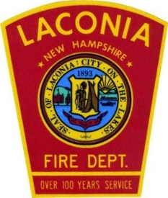

Laconia Fire Department

Special Event Planning Guide
Fire Prevention Division 848 North Main Street
Laconia, New Hampshire 03246 (603) 524-6881
LaconiaFire.com

Overview

Welcome to the Laconia Fire Department Special Event Planning Guide.

This booklet is designed to provide information and fire safety regulations necessary to have a successful and safe event. It is intended to cover the basic guidelines that should be followed when planning and conducting your activities. It must be noted that other regulations, not contained within this document may apply. Careful consideration should be given to ensure that all interested party’s are included in planning for the event.

EVENT PLANNING FLOW CHART

YES
CONTACT LACONIA POLICE
CONTACT PLANNING OFFICE
IS THE EVENT OPEN TO THE PUBLIC?

NO YES
OUTDOOR EVENT? LARGE CROWDS?
RULES FOR INDOOR ASSEMBLY APPLY

YES
USING PROPANE?

YES
USING TENTS OR TEMP. STRUCTURES?
CONTACT LACONIA FIRE AND CODE

YES
CONTACT LACONIA HEALTH OFFICER
FOOD TO BE SERVED?
CONTACT LACONIA FIRE

YES

Definitions:

Place of Assembly: An occupancy (1) used for a gathering of 50 or more persons for deliberation, worship, entertainment, eating, drinking, amusement, awaiting transportation, or similar uses; or
- used as a special amusement building, regardless of occupant
load.

Special Amusement Building: A building that is temporary, permanent, or mobile and contains a device or system that conveys passengers or provides a walkway along, around, or over a course in any direction as a form of amusement arranged so that the egress path is not readily apparent due to visual or audio distractions or an intentionally confounded egress path, or is not readily available due to the mode of conveyance through the building or structure.

Special Event: A gathering, collecting, assembly or congregation of persons, with or without the levy of an admission fee, that is open to the general public.

Temporary Structure: Anything, with or without a roof, constructed or erected with a fixed location on the ground or attached to something having a fixed location on the ground on a temporary basis.

Tent: A temporary structure with a roof usually made of canvas or other fabric material. For the purpose of this Guideline, a tent is such a structure, over 400 ft ² used for entertainment, exhibition, or worship. Tents for private parties do not fall under this provision.

Vendor: All persons, both principal and agents, including those persons whose principal place of business is not in the state, who engage in the temporary or transient business in this state, whether in one locality or traveling from place to place, selling goods, wares and merchandise.

Vendor Site: A delineated area or space in which a vendor conducts their activities.

Planning

Planning for your event should begin as soon as possible. Contact should be made with the Fire Prevention Division Office at the Laconia Fire Department at 603 524-6881.

Many other city departments have regulations governing special events which may require permits, inspections, traffic orders or City Council approval. They should also be contacted when in the beginning your stages of planning.

Contact Information:
Laconia City Manager: | 603 527-1270
Laconia Code Enforcement: | 603 527-1293
Laconia Police: | 603 524-5151
Laconia Fire: | 603 524-6881
Laconia Planning and Zoning | 603 527-1264
Laconia Public Works | 603 528-6379

Please provide valid contact names and telephone numbers for the individuals planning the event. Contact numbers, including cell phone information, will also be required for those responsible during the event.

Information should include the type of event, estimated number of attendees, event duration and location, parking requirements, city support services needed and associated hazards such as propane usage.

Rules Governing the Use of Propane

Minimum size temporary tank is 23 gallons (100 LBS.) Maximum size tank is 100 gallons (420 LBS.)
The following exceptions apply:
Tanks permanently attached to food service trailers, 2 40-lbs cylinders maximum.
20 lbs cylinders supplying residential gas grills or portable food carts, 2 cylinders maximum per site.
Tanks shall be on a firm surface not exceeding 5 degrees of slope and shall not be located along or under any walkway or customer service area.
Tanks shall be attached to appliances via a rubber hose assembly. Larger venues may use black iron pipe where gas demand makes this necessary. All gas piping subject to physical damage by vehicles, pedestrians and employees shall be protected.
All installations are subject to inspection and approval of the Laconia Fire Department.
No tanks shall be filled during normal operating hours or at times of increased public activity.
Tanks shall be removed within 24 hours of the conclusion of the event.

Propane Tanks Approvals

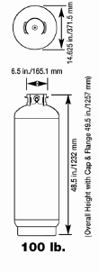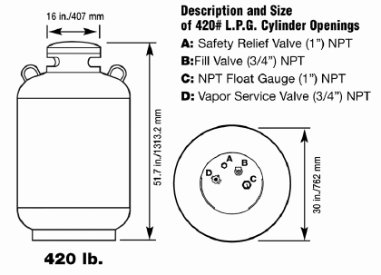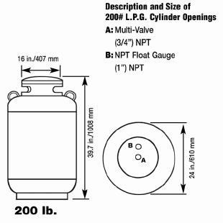
Certain conditions (duration of the event and projected gas usage) may impact the implementation of these regulations.

Contact the Laconia Fire Prevention Division for special conditions regarding propane storage tanks.

Temporary Structures and Tents

Tents shall be erected to cover not more than 75 percent of the premises, unless otherwise approved by the authority having jurisdiction.
A minimum of two (2), separate and remote, emergency exits shall be provided from each tent or compounded area.
Each exit shall be properly marked by self-illuminated exit signage.
Adequate emergency lighting shall be provided at floor level along each egress pathway.
All tent fabric shall meet the flame propagation performance criteria contained in NFPA 701
One of the following shall serve as evidence that the tent fabric materials have the required flame propagation performance:
- The authority having jurisdiction shall require a certificate or other evidence of acceptance by an organization acceptable to the authority having jurisdiction.
- The authority having jurisdiction shall require a report of tests made by other inspection authorities or organizations acceptable to the authority having jurisdiction.
There shall be a minimum of 10 ft between stake lines.
Adjacent tents shall be spaced to provide an area to be used as a means of emergency egress.
Where 10 ft between stake lines does not meet the requirements for means of egress, the distance necessary for means of egress shall be determined by the authority having jurisdiction.
Tents not occupied by the public and not used for the storage of combustible material shall be permitted to be erected less than 10 ft from other structures where deemed such close spacing to be safe from hazard to the public. All other temporary structures must meet the 10 ft setback requirement.

Tents, each not exceeding 1200 ft² in ground area and located in fairgrounds or similar open spaces, shall not be required to be separated from each other, provided that safety precautions meet the approval of the authority having jurisdiction.

Temporary Structures and Tents

The placement of tents relative to other structures shall be at the discretion of the authority having jurisdiction, with consideration given to occupancy, use, opening, exposure, and other similar factors.
The ground enclosed by any tent, and the ground for a reasonable distance but for not less than 10 ft outside of such a tent, shall be cleared of all flammable or combustible material or vegetation that is not used for necessary support equipment. The clearing work shall be accomplished to the satisfaction of the authority having jurisdiction prior to the erection of such a tent. The premises shall be kept free from such flammable or combustible materials during the period for which the premises are used by the public.
Fuel- Fired Heaters:
  - Only listed heating devices shall be used.
  - Fuel-fired heaters and their installation shall be approved by the authority having jurisdiction.
  - Containers for liquefied petroleum gases (other than those that are part of an appliance assembly) shall be installed not less than 60 in. from any tent.
  - Heaters shall be rigidly secured to the pavement or properly supported to eliminate the possibility of tipping.
Electric Heaters:
- Only listed heaters shall be permitted.
- Heaters used inside a tent shall be approved by the authority having jurisdiction
- Heaters shall be connected to electricity by electric cable that is suitable for outside use and is of sufficient size to handle the electrical load.
All temporary structures, including decks, platforms, stages, stairs or booths shall require a building permit and inspection from the Code Enforcement Office.

Fire Extinguishers

All assembly tents, enclosed temporary structures, compounds and large venues shall be equipped with at least one (1) portable fire extinguisher with a minimum rating of 20-BC at each bar, food service and stage area.
Large food service establishments utilizing LP Gas, or using deep-fat fryers, grills, griddles, ovens or burners of any kind shall be
equipped with at least one (1) portable fire extinguisher with a minimum rating of 20-BC and one (1) Type K extinguisher with a valid inspection tag dated within the past twelve (12) months.

Electrical Safety
Facilities utilizing electricity not supplied by a self-contained generator, shall comply with NFPA 70 National Electrical Code (Temporary Wiring) and the requirements of the City of Laconia Code Enforcement Director.

The property owner shall provide a minimum of one 15–ampere electric power connection to each vendor.

Power strips or extendors shall meet requirements of the City of Laconia Code Enforcement Director.

Electrical wiring for lighting, where installed inside of tents and concessions, shall be securely installed and, where subject to physical damage, shall be provided with mechanical protection. All lamps for general illumination shall be protected from accidental breakage by a suitable guards.

Electrical Safety (cont.)

Where flexible cords or cables are used, they shall be listed for
extra-hard usage. Where flexible cords or cables are used and are not subject to physical damage, they shall be permitted to be listed for hard usage. Where used outdoors, flexible cords and cables shall also be listed for wet locations and shall be sunlight resistant. Extra-hard usage flexible cords or cables shall be permitted for use as permanent wiring on portable amusement rides and attractions where not subject to physical damage.

Flexible cords or cables accessible to the public shall be arranged to minimize the tripping hazard and shall be permitted to be covered with nonconductive matting, provided that the matting does not constitute a greater tripping hazard than the uncovered cables. It shall be permitted to bury cables.

All electrical distribution system wiring shall be properly grounded and shall not be supported by metal fences or other similar conductive structures.

Use of Flammable Liquids

No flammable liquids shall be stored at any vending site without the approval of the Laconia Fire Department.

Appropriate storage for fuel containers shall be provided.

Outdoor Burning

No outdoor burning shall be conducted by places of assembly without prior approval of the Deputy Chief of Fire Prevention or Fire Chief.

